**DISCO LIGHTS**

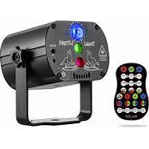**Disco lighting – it’s fast moving and exciting, both on the dance floor and behind the scenes. Disco lighting manufacturers are continually fighting tooth and nail to provide customers with the most exciting lighting rigs or large scale installations. And, with the nights being long at the minute, now is arguably a great time for you to look at the different LED disco lighting available to you for this year!**

